Template and Guidelines for IWCN 2027 Abstracts
(Title in 24-pt Times, Title Case)
First A. Author¹, Second B. Author², and Third C. Author¹
¹Department, Organization, City, Country
²Department, Organization, City, Country
Corresponding author: author@example.edu

Abstract—This document is the template for abstracts submitted to the 2027 International Workshop on Computational Nanotechnology (IWCN 2027), April 19–22, 2027, Hsinchu, Taiwan. Abstracts for review are 2 pages (A4), including figures and tables; authors of accepted abstracts submit a 4-page final paper in the same format for the proceedings. All files must be submitted as PDF. Please replace this text with an abstract of 100–200 words summarizing the problem, the method, and the main results.
Keywords—computational nanotechnology, device simulation, quantum transport, first-principles calculation
I. Introduction
IWCN is the leading forum for discussing current trends and future directions in computational nanotechnology. The series began in 1992 as the International Workshop on Computational Electronics (IWCE) and was renamed IWCN in 2016. This template is based on the IEEE conference template and is used for both the 2-page abstract and the 4-page final paper; please keep the page size, margins, and fonts unchanged so that accepted papers can be processed for publication.
II. Submission Requirements
• Abstract for review: 2 pages (A4), including figures and tables.
• Final paper (after acceptance): 4 pages (A4), including figures, tables, and references, for the proceedings planned for IEEE Xplore.
• Format: PDF, all fonts embedded, file size below 10 MB.
• Language: English only. Do not use Asian (double-byte) fonts.
• Submission: through the online submission system linked from https://iwcn2027.nycu.site/submission by November 22, 2026 (23:59 Taipei time, UTC+8). Abstracts sent by e-mail will not be considered.
• Presenting author: at least one author must register and present the work in person.
III. Formatting
A. Text
Use 10-pt Times New Roman for the body text in two columns. Section headings are numbered with Roman numerals and written in small capitals; subsection headings are in italics. Define abbreviations and acronyms the first time they are used in the text.
B. Equations
Number equations consecutively, with equation numbers in parentheses flush with the right margin, as in (1). Use the Word equation editor and SI units.
[−(ħ²/2m*)∇² + U(r)] ψ(r) = E ψ(r) (1)
C. Figures and Tables
Place figures and tables at the top or bottom of a column. Large figures may span both columns. Captions go below figures and above tables. Make sure axis labels and legends remain readable when printed (at least 8 pt). Fig. 1 shows an example.
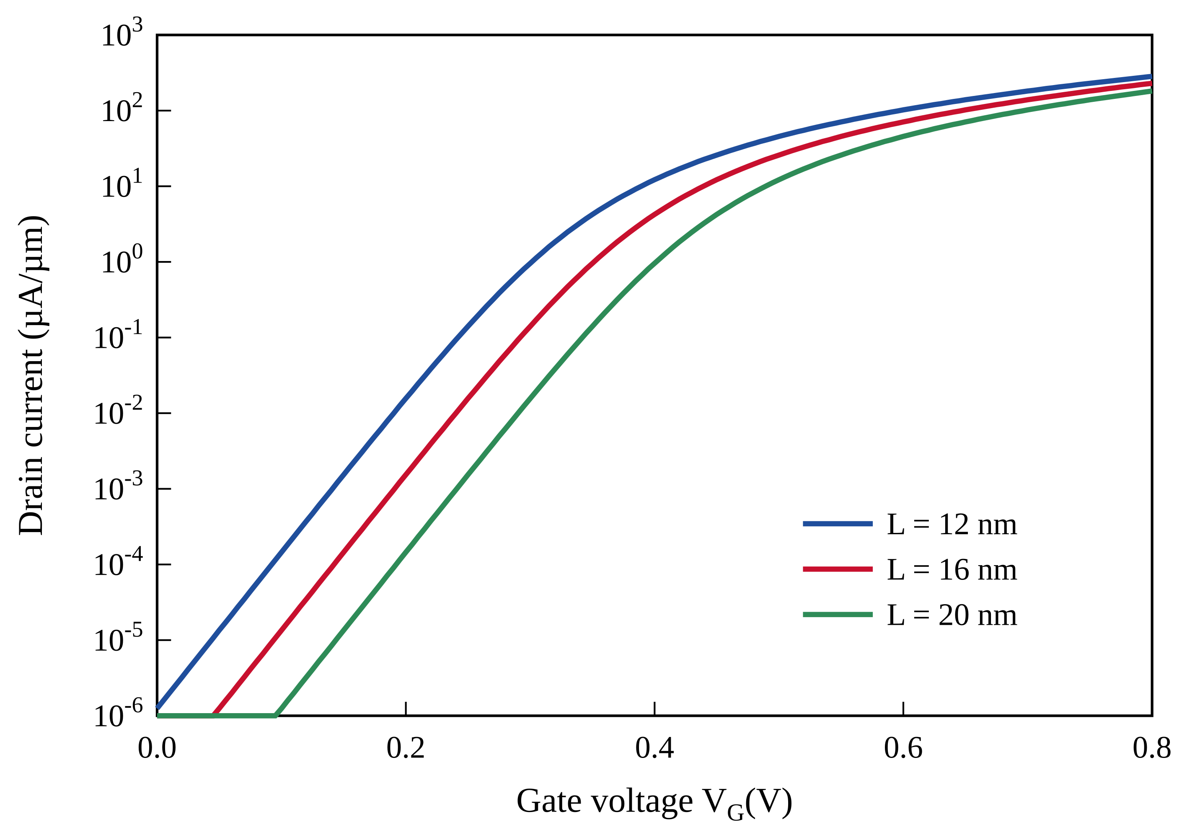
Fig. 1. Example figure: simulated transfer characteristics for three gate lengths. Replace with your own figure.
TABLE I
Example Table
Gate length | Vth (V) | SS (mV/dec) | Ion (µA/µm)
12 nm | 0.30 | 97 | 280
16 nm | 0.35 | 97 | 230
20 nm | 0.40 | 97 | 180
IV. Results and Discussion
Describe your method, results, and their significance here. Abstracts are reviewed by the Technical Committee for originality, technical quality, and relevance to the workshop topics.
V. Conclusion
Summarize the main contribution of the work in a few sentences.
Acknowledgment
Acknowledge funding agencies and collaborators here, if applicable.
References
[1] A. Author and B. Author, “Title of the paper,” IEEE Trans. Electron Devices, vol. 70, no. 1, pp. 1–8, Jan. 2023.
[2] C. Author, Title of the Book, 2nd ed. City, Country: Publisher, 2020.
[3] D. Author et al., “Title of the conference paper,” in Proc. Int. Workshop Comput. Nanotechnol. (IWCN), 2025, pp. 1–2.

